Campbell, Tamara (from Linked In)
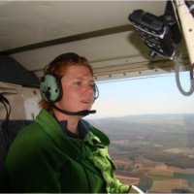

Bachelor of science (Forestry) ANU 1997 – 2000. Forester Forestry Corporation NSW February 2001 – . Forester Forests NSW August 2002 – . President Women and Firefighting Australasia June 2011 – .

